附件一：《国际期刊预警名单(试行)》 (2021)

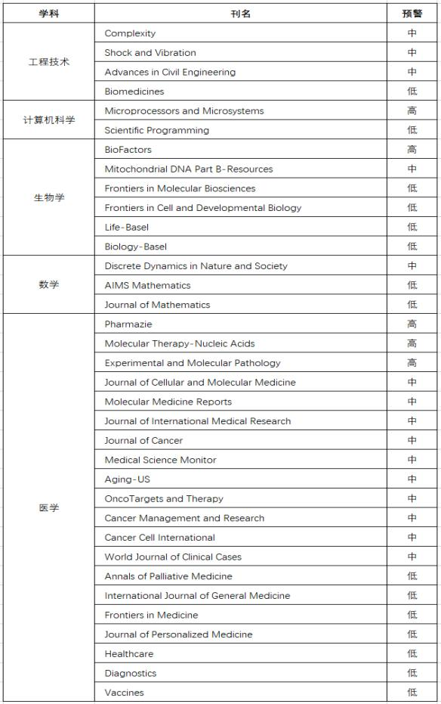

附件二：《国际期刊预警名单(试行)》 (2020)

|  |  |  |
| --- | --- | --- |
| 学科 | 刊名 | 预警 |
| 材料科学 | Metals | 低 |
| Coatings | 低 |
| Materials | 低 |
| JOURNAL OF NANOSCIENCE AND NANOTECHNOLOGY | 低 |
| 地球科学 | Minerals | 低 |
| Atmosphere | 低 |
| 工程技术 | Artificial Cells Nanomedicine and Biotechnology | 高 |
| Advances in Civil Engineering | 中 |
| INTERNATIONAL JOURNAL OF ENERGY RESEARCH | 中 |
| MATHEMATICAL PROBLEMS IN ENGINEERING | 中 |
| SENSORS | 低 |
| Energies | 低 |
| Applied Sciences-Basel | 低 |
| Polymers | 低 |
| Electronics | 低 |
| Processes | 低 |
| COMPLEXITY | 低 |
| Desalination and Water Treatment | 低 |
| 化学 | International Journal of Electrochemical Science | 中 |
| Catalysts | 低 |

|  |  |  |
| --- | --- | --- |
|  | MOLECULES | 低 |
| NATURAL PRODUCT RESEARCH | 低 |
| ZEITSCHRIFT FUR KRISTALLOGRAPHIE-NEW CRYSTAL  STRUCTURES | 低 |
| 环境科学  与生态学 | Sustainability | 中 |
| Water | 低 |
| 计算机科  学 | IEEE Access | 中 |
| 农林科学 | Agronomy-Basel | 低 |
| 生物学 | JOURNAL OF CELLULAR BIOCHEMISTRY | 高 |
| JOURNAL OF CELLULAR PHYSIOLOGY | 中 |
| BIOSCIENCE REPORTS | 中 |
| Biomed Research International | 中 |
| BIOFACTORS | 低 |
| Plants-Basel | 低 |
| Cells | 低 |
| 数学 | Boundary Value Problems | 高 |
| Advances in Difference Equations | 高 |
| JOURNAL OF INEQUALITIES AND APPLICATIONS | 中 |
| Mathematics | 低 |
| 医学 | European Review for Medical and Pharmacological  Sciences | 高 |

|  |  |  |
| --- | --- | --- |
|  | International Journal of Clinical and Experimental  Pathology | 高 |
| MEDICINE | 高 |
| International Journal of Clinical and Experimental  Medicine | 高 |
| BIOMEDICINE & PHARMACOTHERAPY | 中 |
| EXPERIMENTAL AND MOLECULAR PATHOLOGY | 中 |
| BRAZILIAN JOURNAL OF MEDICAL AND BIOLOGICAL  RESEARCH | 中 |
| Cancer Biomarkers | 中 |
| INTERNATIONAL JOURNAL OF IMMUNOPATHOLOGY  AND PHARMACOLOGY | 中 |
| ONCOLOGY RESEARCH | 中 |
| American Journal of Cancer Research | 中 |
| MEDICAL SCIENCE MONITOR | 中 |
| Oncology Letters | 中 |
| Experimental and Therapeutic Medicine | 中 |
| OncoTargets and Therapy | 中 |
| ONCOLOGY REPORTS | 中 |
| Molecular Medicine Reports | 中 |
| INTERNATIONAL JOURNAL OF MOLECULAR MEDICINE | 中 |
| JOURNAL OF INTERNATIONAL MEDICAL RESEARCH | 中 |

|  |  |  |
| --- | --- | --- |
|  | American Journal of Translational Research | 中 |
| Journal of Biomaterials and Tissue Engineering | 中 |
| Aging-US | 中 |
| LIFE SCIENCES | 低 |
| Journal of Clinical Medicine | 低 |
| International Journal of Environmental Research and  Public Health | 低 |
| Acta Medica Mediterranea | 低 |
| 综合性期  刊 | Symmetry-Basel | 低 |